**This document contains photos and links to videos of bugs:**

1. User can enter invalid email in create an account form:

<https://www.loom.com/share/1e0176d90d7f4e679f449301e945eb46>

1. User is not able to sort products by lowest price first:

<https://www.loom.com/share/a8755a48cd9946a084f5806e378d4381>

1. User can enter invalid title and comment in write a review form:

<https://www.loom.com/share/4e4dc4a054a24f919751c8388d3b8fe8>

1. User can enter invalid email in newsletter field

<https://www.loom.com/share/42ab0345652047d1b8f4397e9d8d5a66>

1. User is not able to filter products by color in the catalog

<https://www.loom.com/share/133419978fcb4358af6eb6ef99a6da87>

1. User can't see stores with the correct addresses on Google Maps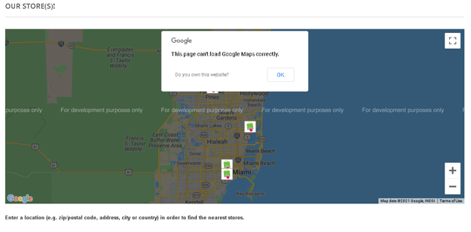
2. In create an account form user can enter city and postal code that are not from USA